Miniscope DAQ PCB Assembly Information

**Assembly:**

* 1 BGA (.8mm pitch)
* Through Hole:
  + Unique components: 4
  + Total parts: 6
  + All on top layer
* Surface Mount:
  + Unique components: 49
  + Smallest footprint: 0402
  + Total parts: 179
  + All on top layer
  + U11, U12, U14 LED orientation is shown below:

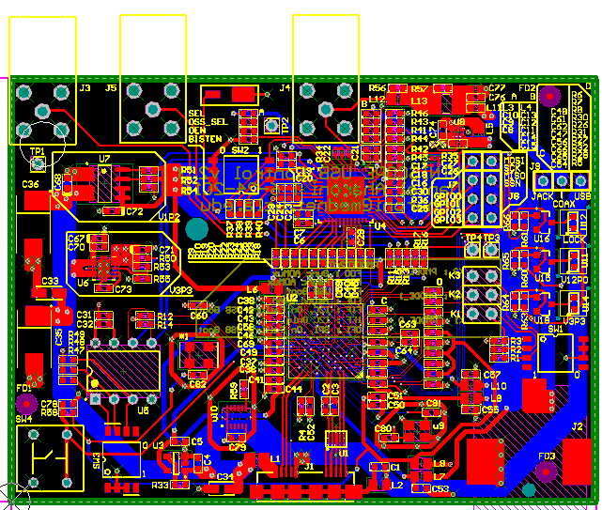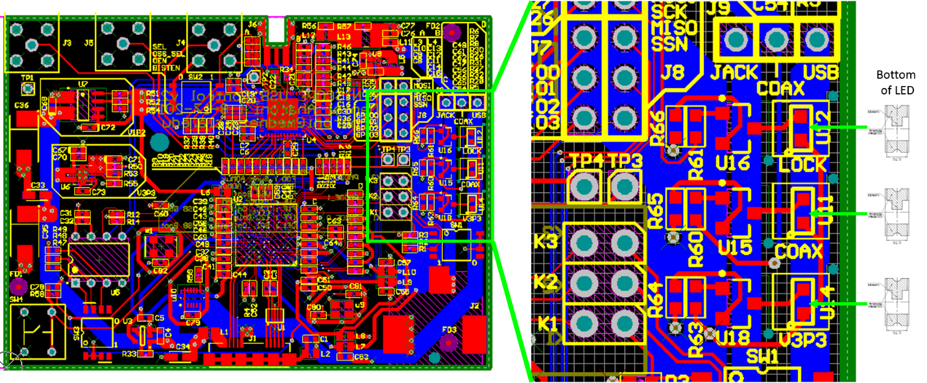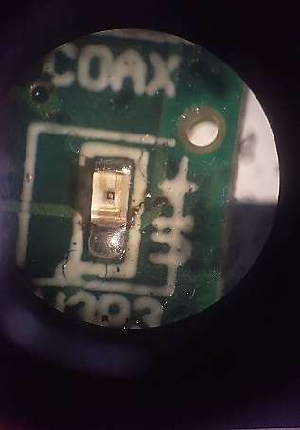

**Top of LED**